DRAFT Incomplete Readme File (will be updated periodically)
Brief Introductory Note on GOES 8-12 Magnetometer Data --- 9/1/08 Dr. Howard J. Singer
1. Coordinate description for historically used PEN system:
Hp: magnetic field vector component, points northward, perpendicular to orbit plane which for a zero degree inclination orbit is parallel to Earth's spin axis.
He: magnetic field vector component, perpendicular to Hp and Hn and points earthward.
Hn: magnetic field vector component, perpendicular to Hp and He and points eastward.
Ht: total field
2. Data Caveats:
a. Magnetic Field Accuracy and interference: GOES 8-12 spacecraft are 3-axis stabilized and there is only one opportunity for a spin maneuver at the beginning of the mission to determine on-orbit offsets. There are additional complications that result from needing to know the changing offsets introduced by torquer coils on the satellites. Though comparisons of data to model fields during quiet times, we are doing rather well with the offsets, but I can't give an exact number for the accuracy. We continue to look at comparisons of data and models, and data to other nearby spacecraft encounters. I am interested in anything learned by the user, or working with the user to help interpret the data, or to answer questions. While we have put in a significant effort to remove the effects of torquer coil interference, in the 0.512 s data there can be small, typically less than 1 nT spikes in the data at the time of torquer current changes. More information on this topic is included the more extensive “readme file.” This file is a living document that will be updated periodically.
b. GOES 10 is an older satellite, and hasn’t been "operational" since about July 2006. The capability to keep it at 0 degrees inclination, or within a few tenths of a degree, no longer exists. The inclination is now several degrees. This will have a small diurnal effect on the data that can be handled with proper coordinate transformations that take into account the changing satellite location.
9/1/08 – Dr. Howard J. Singer (contact: howard.singer@noaa.gov)
NOAA Space Weather Prediction Center
prepared with Ann Newman and Lorne Matheson
NOAA Space Weather Prediction Center

GOES (Geostationary Operational Environmental Satellite) Magnetometer Data for the GOES 8-12 Satellite Series

1. Overview of GOES 8-12:

The GOES 8-12 satellite series were built by Space Systems/Loral. The launch date for each of the satellites is:

GOES 8 4/13/94
GOES 9 5/23/95
GOES 10 4/25/97
GOES 11 5/03/00
GOES 12 7/23/01

During normal operations, there are two operational GOES satellites with one satellite located at 75 degrees west geographic longitude and the other at 135 degrees west geographic longitude. There are occasions when one or more of the non-operational GOES satellites are in on-orbit storage (no magnetometer data available), or in use supporting other meteorological functions (sometimes magnetometer data available). The satellites are 3-axis stabilized during operations. The locations of the satellites as a function of date are provided in a data file separate from the satellite data.

2. Magnetometer Instrument Description

The following brief instrument description, written after the launch of GOES 8 and 9, but that applies to GOES 8-12, is reproduced, in part, from:

Singer, H.J., L. Matheson, R. Grubb, A. Newman and S.D. Bouwer, Monitoring Space Weather with the GOES Magnetometers. SPIE Conference Proceedings, Vol. 2812, p. 299-308, GOES-8 and Beyond, Edward R. Washwell, ed., 1996
The magnetometers on the three-axis stabilized GOES I-M (called GOES 8-12 after launch) series of satellites are three-axis fluxgate magnetometers manufactured by the Schonstedt Instrument Company and integrated on the spacecraft by Space Systems/LORAL. The magnetometer electronics are inside the spacecraft, and the sensors are mounted on a three-meter boom attached at the north west corner of the anti-Earth panel, with the primary sensor at the end of the boom and a second redundant sensor located 0.3 meters inboard of the first. Only one magnetometer may be operated at a time. Each magnetometer axis is measured once a telemetry frame (0.512 seconds), with a 42 millisecond delay between sampling successive axes. To reduce aliasing, each of the three-axis magnetometer outputs is filtered through a five-pole 0.5 Hz Butterworth low-pass filter.
The magnetometer range is ± 1000 nanoTesla (nT), and is measured by a 16 bit analog-to-digital converter providing 0.03 nT sensitivity. With temperature compensation of the sensors and electronics, the accuracy of the instrument is 1 nT. The instruments are monitored for proper operation by adding a series of small fixed currents to a set of auxiliary windings during weekly calibrations and checking for proper magnetometer gains and transient responses.
To insure accurate measurements, the GOES magnetometers are thoroughly tested and calibrated. Prior to launch, the instruments are temperature calibrated, and sensor gains and offsets are determined. Because stray fields, generated by the spacecraft, can severely contaminate the measurement, a stray-fields test program identifies whether or not various spacecraft systems produce magnetic signatures that are likely to be detected in orbit. If there is a detectable signature, it is either reduced to an allowable limit through hardware modifications, or a correction scheme is instituted in the ground-based data processing. Efforts are also made to minimize and control magnetic materials on the spacecraft and boom. An initial calibration of the spacecraft torquer coils is also made prior to launch.
Absolute magnetic field measurements require accurate knowledge of magnetometer offsets that result from the spacecraft and the sensor electronics. A spinning spacecraft continuously provides the opportunity to measure these values for the spin plane sensors; however, on the three-axis stabilized GOES-8 and GOES-9, we must rely on a one time satellite maneuver. In orbit, just after the magnetometer boom deployment, the spacecraft is rotated about 3 axes to determine magnetic offsets that result from a combination of the spacecraft field and the magnetometer sensors. This maneuver cannot be performed again after all spacecraft appendages are deployed and the spacecraft becomes operational. Following the initial offset determination, data comparisons with magnetic field models are used to monitor for any major changes in these offsets.
On GOES-8 and GOES-9, the spacecraft torquer coils are the major system contributing offset fields to the measurements that must be corrected during data processing. The magnetic torquers, along with two momentum wheels, a reaction wheel, the solar panel trim tab and 22 thrusters, maintain the proper attitude of the spacecraft. They are controlled by an attitude and orbit control subsystem. At the launch of GOES-8, the torquers could change current at a 20 minute interval. The currents could change from full scale of one polarity to full scale of the other polarity at one of these steps, could make a small step, or the current might not change at all at one of the possible current change times. A maximum size step can produce as much as a 400 nT magnetic signature at the magnetometer sensors. The control of the torquers has evolved into a small fixed size step in the torquer current at a much faster rate. The current operation of the torquers sets the current change at a level that causes a 1.5 nT magnetometer step at a minimum change interval of 2.56 seconds. In actual operation not every possible change interval has a torquer current change. GOES-8 torquer currents change from 600 to 800 times a day.
A calibration between torquer currents and magnetic field signatures was made both on the ground and in space for correcting the magnetic field measurement; however, on GOES-8, noise in the torquer current telemetry introduced artificial noise in the “corrected” magnetic field at the few nanoTesla level. A correction has been instituted on GOES-8, and will be included on following spacecraft, to allow use of torquer command data for torquer current correction. The problem has been further dealt with on GOES-9, and future spacecraft, by filtering the torquer current telemetry before it is transmitted.

3. Magnetometer Data Processing and Data Files

The magnetometer data are downlinked from the spacecraft in real-time to the NOAA Space Weather Prediction Center (SWPC) in Boulder, CO. The data from the raw Command and Data Acquisition (CDA) telemetry stream are processed by pre-processors at SWPC and from there 1-minute averages are distributed to SWPC Space Weather Operations, as well a archived at NOAA’s National Geophysical Data Center (NGDC) and NASA’s Coordinated Data Analysis Web (http://cdaweb.gsfc.nasa.gov/). The raw high-resolution data are corrected and processed at NOAA’s SWPC, and later archived at NGDC as described in this memo.

The major issue for processing the high-resolution data is correction for the magnetic signature of spacecraft torquer currents as briefly discussed above. In normal operation, the magnetometer samples its three axes every 0.512 seconds, synchronized with the telemetry frames. The magnetometer has an anti-aliasing low-pass filter on each axis. As part of the attitude control on the spacecraft, there are two magnetic torquers. At the magnetometers, these torquers can generate magnetic fields larger than the ambient fields to be measured. Therefore signals from these torquer currents need to be removed. The torquer currents are measured at the same rate as the magnetometer rate, and the currents are used to correct the magnetometer measurements.

However, the torquer currents were not low-pass filtered. As a result, large instantaneous steps in the torquer currents show up in the magnetometer data as a delayed, slowly rising wave with some ringing, just what one would expect from the magnetometer low-pass filters. The so-called “Farthing coefficients” simulate, from a short past history of the torquer measurements, the effects of the magnetometer filters. The torquer current changes are asynchronous with the telemetry frames and the timing between these events must be measured to a eighth of a telemetry frame interval for good performance. The transient responses in changes in torquer currents are reduced, but not eliminated for large changes in torquer currents.

The telemetry with timing was not available early in the life of GOES-8. Additionally, some operating modes of the satellite do not have that data, but it is available for more than 95 percent of the later data. When the additional timing telemetry is not available, a simpler method is used, that is reasonable, but not as effective. Description will be in an update to this file.

The GOES magnetic field data are provided in two different types of files: 0.512 second high-resolution files and 1-minute average files. In each case, the vector magnetic field is given in the spacecraft (s/c) earth-referenced coordinate system: Hp, He, Hn, and Ht, where Hp is perpendicular to the satellite orbital plane, or parallel to Earth's spin axis in the case of a zero degree inclination orbit; He is perpendicular to Hp and directed earthwards; Hn is perpendicular to both Hp and He and directed eastwards; and Ht is the total field.

Note that magnetic field values have been replaced with missing data values during calibration periods. Also, note that there can be small jumps in the data (typically < 1 nT) when the torquer counts go through 0. The magnitude of the effect can be different for different spacecraft. (Figure 1)

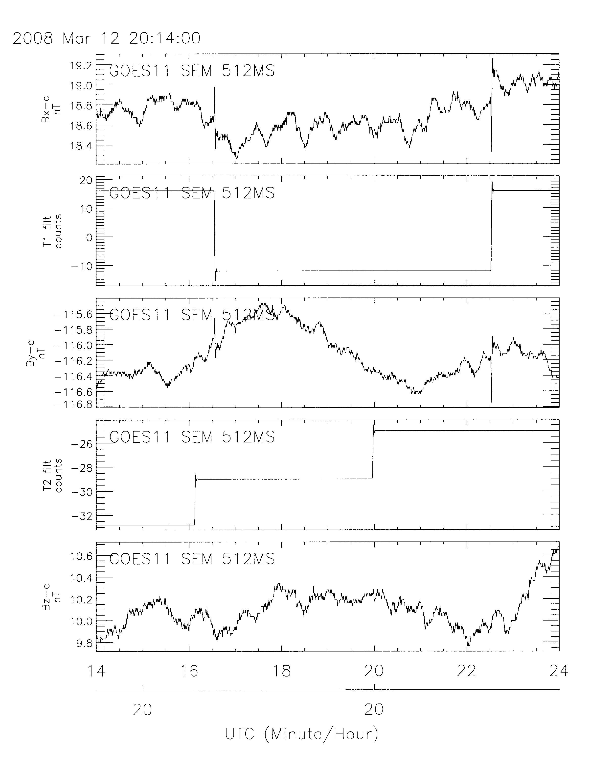
Figure 1: Example of GOES magnetometer high-resolution data corrected for satellite torquer current interference. Small spikes remain seen here resulting from torquer 1 (T1).

Spacecraft Offsets, Torquer Offsets and Torquer Constants

There exists one opportunity at the beginning of each mission to perform a spacecraft rotation maneuver to determine magnetometer offsets. These offsets are used through the duration of each satellite's lifetime.

Approximate coefficients are:

0.8 milliampere per torquer current count
4 counts per torquer current command step (3.2 milliampere per command step)
410 milliamperes full scale current
32 magnetometer counts per nT (approximate)
8 torquer step counts can be up to approximately 0.5 nT (depends on axis, which torquer, which satellite, etc.)

Data included in the 0.512 s data file:

Date-time: The date and time of the data
Hp: corrected magnetic parallel field
He: corrected magnetic earthward field
Hn: corrected magnetic normal eastward field
Ht: corrected magnetic total field
Data Quality Flag: An integer with a value from 1 through 7 indicating data quality, with
1 and 2 being no data, and 7 being the best data.
Possible data quality values:
0=no satellite data
1=no Magnetometer data
2=satellite is in storage (spinning)
mode or non-standard attitude
3=satellite is in calibration mode
4=3-pt averaging failed
5=torquer value not adjusted for commands
6=smoothed with commands but not with
Farthing coefficients
7=best quality: smoothed with commands
and Farthing coefficients
Commands are not always available in the telemetry,
in which case, a 3-point average is done.
Torquer 1 filtered counts
signed counts smoothed by
3-point average, delayed, OR
smoothed by Farthing coefficients
Torquer 2 filtered counts
signed counts smoothed by
3-point average, delayed, OR
smoothed by Farthing coefficients

Data included in the 1-minute averaged data file:

Date-time: The date and time of the data
Hp: corrected magnetic parallel field
He: corrected magnetic earthward field
Hn: corrected magnetic normal eastward field
Ht: corrected magnetic total field
Data Quality Flag: An integer with a value from 1 through 7 indicating data quality, with
1 and 2 being no data and 7 being the best data.
possible data quality values:
0=no satellite data
1=no Magnetometer data
2=satellite is in storage (spinning)
mode or non-standard attitude
3=satellite is in calibration mode
4=3-pt averaging failed
5=torquer value not adjusted for commands
6=smoothed with commands but not with
Farthing coefficients
7=best quality: smoothed with commands
and Farthing coefficients
Commands are not always available in the telemetry,
in which case, a 3-point average is done.

For additional info., contact Dr. Howard Singer (howard.singer@noaa.gov), Lorne Matheson, or Ann Newman at NOAA/Space Weather Prediction Center.

Coefficients for spacecraft voltages and temperatures are from a volume of the Spacecraft Data documentation; there is a separate volume for each satellite. (Ref: Spacecraft Operations Handbook, DRL 503-02, Space Systems/Loral, 3825 Fabian Way, Palo Alto CA 94303-4604).

Magnetometer coefficients are in the Data and Calibration Handbook for Space Environment Monitor, separate volume for each spacecraft. (Ref: DRL 311-01, Space Systems/Loral, 3825 Fabian Way,Palo Alto CA 94303-4604).

Additional coefficients were determined for each satellite during Post Launch Test (PLT).

