Readme file for the DAILI Data Sets
James Hecht
Data Archive for the NASA DAILI CubeSat Mission:
NASA Award Number: 80NSSC18K0973 (2023)

1. Introduction
The DAILI (Daily Atmospheric and Ionospheric Limb Imager) mission utilized a 6U CubeSat, to measure the airglow on the Earth’s limb day and night from about 140 to 300 km in two colors; the OI (630 nm) redline and part of the O2A (0,0) band near 760 nm. The ratio of these colors, obtained when the atmosphere is sunlit, can provide absolute O₂ density. The theoretical basis for this is found in a GRL paper that describes this technique and that uses data from the NRL/Aerospace RAIDS experiment that was on the ISS (International Space Station) in 2009/2010 (Hecht et al., 2015). DAILI was designed to obtain the same measurements but from a CubeSat. DAILI was launched to the ISS on December 2021 and was deployed from the ISS into an ISS-like orbit at 410 km on 01/26/22. DAIL’s reentered in late June 2022.
The data in these files (either IDL save sets or NCDF files) are from this mission and the purpose of this readme file is to (a) provide an overview of the DAILI mission to provide some context to the reader, (b) provide some examples of the DAILI data, (c) describe the analysis procedure (and provide some examples), and (d) list the array names of that included in the saved datasets. We note that an overview of the DAILI mission was presented at the fall 2022 AGU meeting in Chicago and the slides below are from that presentation.
For this archive the data are in ncdf files. (The IDL save set archive is saved at zenodo-https://doi.org/10.5281/zenodo.8122347 ). All, except for March 3. Include the raw and processed daytime data as described below. On March 3 no processed data are available at this time (July 6 2023). The raw data however allow for future processing.

2. Overview of the DAILI Mission
Figure 1 provides an overview of the experiment.

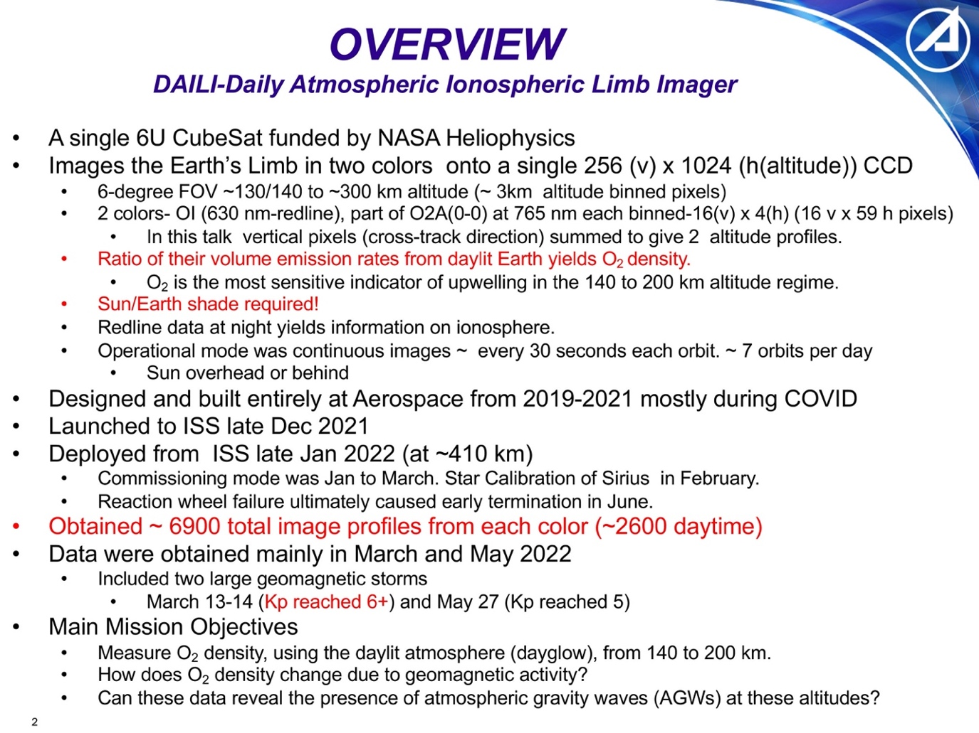
Figure 1. An overview of the DAILI CubeSat Mission.

Figure 2 provides some background as well as a schematic of DAILI viewing the limb.

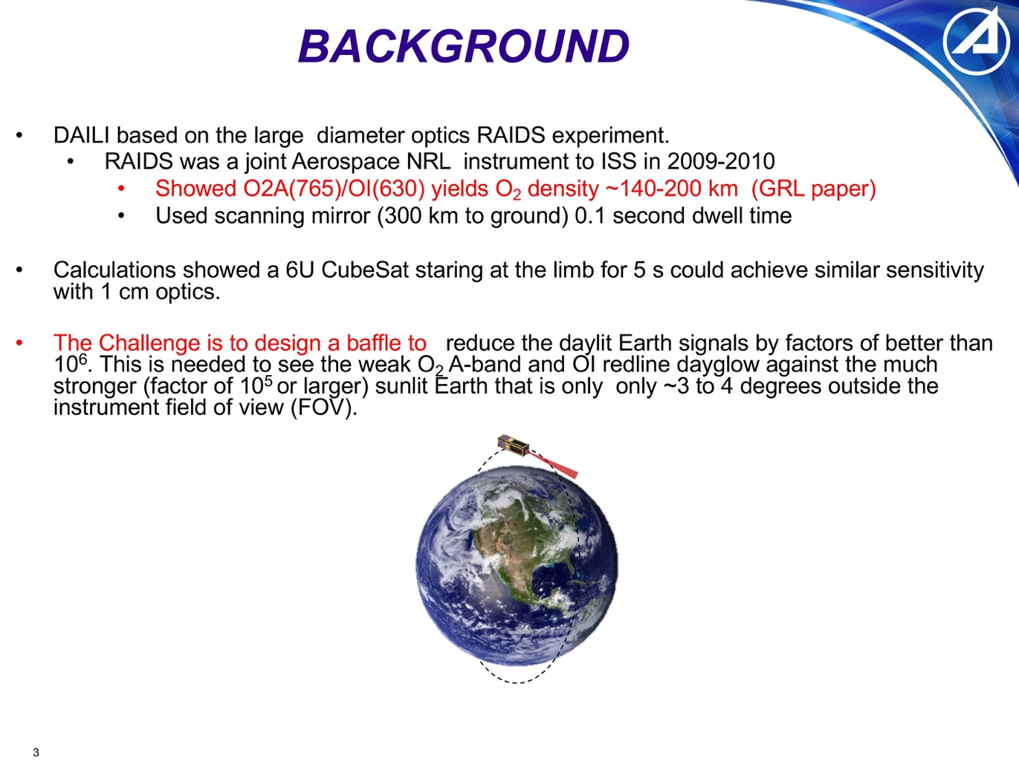
Figure 2. Background for the DAILI CubeSat mission.

Figure 3 has 5 images. The top image presents the optical layout showing the deployed sunshade, the first fold mirror (that is super-polished to reduce scattering) and the two beam splitters that direct the two colors onto two separate portions of the E2V CCD. Not shown is the shutter (a clear glass element at the end of the sunshade and before the first mirror) that kept the instrument clean until it was deployed a few days after DAILI was ejected from the ISS. In the left column are two images of DAILI;(top) on the bench before delivery) and (bottom) looking down the throat of the sunshade. DAILI was painted with a special Nano black paint that reduced scattering. In the right column are two images taken from the initial testing in the laboratory: (Top) A calibration chart imaged onto the full (1024 x 256) CCD. with the signal through the 765 (630) nm channel shown on the left (right). (Bottom) A line plot slice through the top image that was used to spatially calibrate the image. As noted on the bottom of the chart on-orbit images were binned down to 256-horizontal by 16-vertical pixels.
Figure 4 shows DAIL being I deployed from the ISS on 01/26/22.

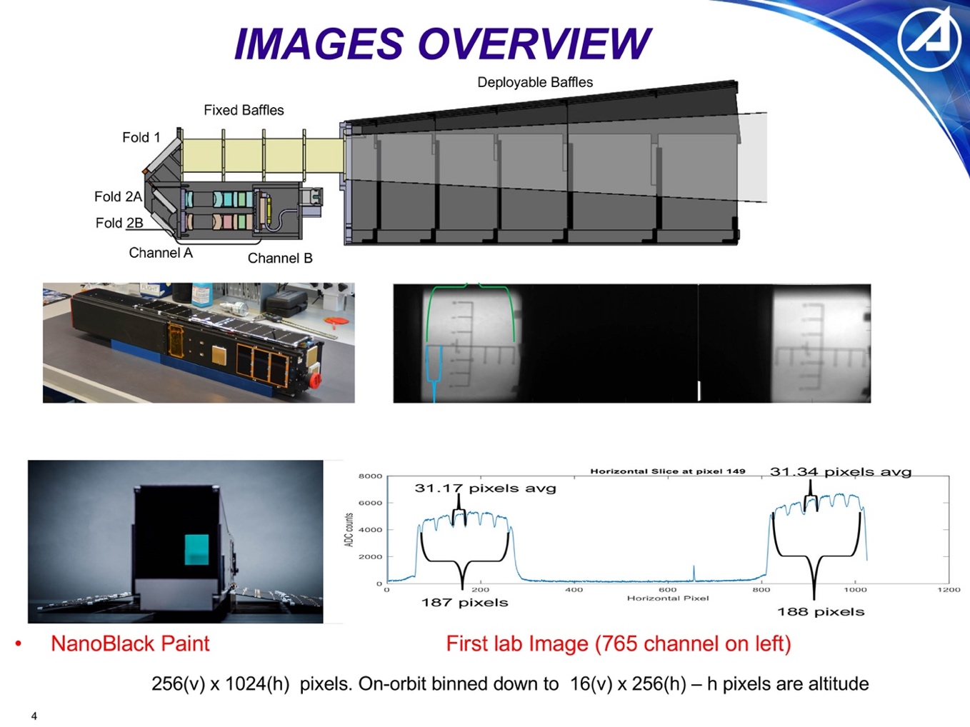
Figure 3. Some images of the DAILI hardware, an optical layout, and some first light da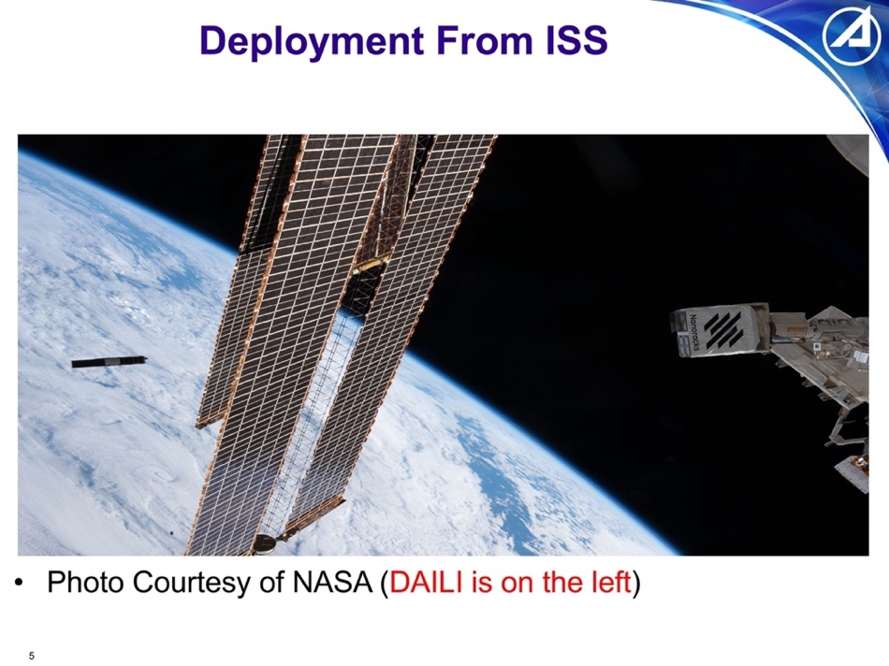
Figure 4. The Deployment of DAILI from the ISS.
Before fully discussing Figure 5 we describe the general storage of the data. On March 18,2022 DAILI obtained 867 images. There is an array in the ncdf and IDL save set files called raw_image that has 256 by 16 by 867 elements. From Figure 4 the on-orbit binned CCD has 256 horizontal h-pixels and 16 vertical v-pixels. Thus, there is an element in the array for each of the 867 images that have 256 CCD h-pixels that are in the altitude direction, and 16 CCD v-pixels that are in the cross-track direction. The plot on the left of Figure 5 shows a slice at v- pixel 8 (where the first pixel is 0) through all of the 256 h-pixels. This slice is for the 81st image (row number 80 in this column of the array where row 0 is the first image). As noted, the region between the baffle vanes is between h-pixels 9 and 58, for the 765 nm channel, and (189 pixels to the right) between h-pixels 198 to 247, for the 630 nm channel. To facilitate analysis (and because none of the pointing data are useful for the interior pixels) almost all the remaining arrays listed in Appendix 4 have 59 x 16 x n elements where n is the number of images on a selected = day. The 59 rows of the first column are the altitude direction h-pixels and the 16 rows of the second column are the cross-track direction v-pixels. Each of the two data arrays are labeled as either 765 or 630, referring to their respective colors. Since they each have identical altitudes there are 59 altitude rows In the tangent point arrays that apply to both channels. All of the provided arrays are listed in Appendix 4.

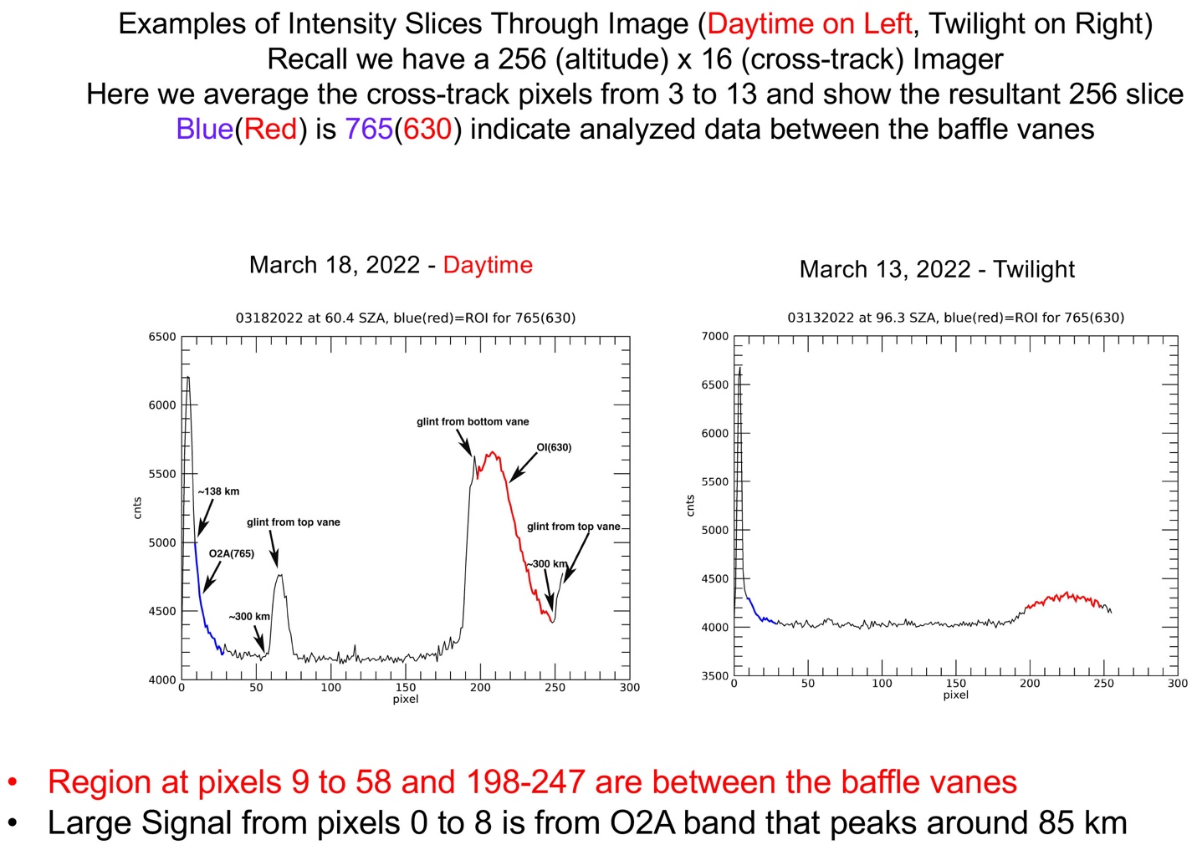

Figure 5. Examples of on-orbit DAILI data

Now we describe Figure 5 that presents some on-orbit data. The plot on the left therefore is a plot of raw data (0:255,8,80) for March 18, 2022. The value at pixel 150 is 4167. The figure is annotated, and it is noted that region between the vane is from pixels 9 to 58. There is an array called tpaltitude that has, for day March 18, 59 x 16 x 867 elements and that gives the tangent point altitude. Here element (9,8,80) is at 136.54 km and element (58,8,80) is at 308.49 km. During the day there is considerable 765 nm signal and even though the vane edge is at pixel 8 the optics are such that the signal still increases until the illumination on the first fold mirror decreases enough to significantly attenuate the signal. Thus, there is still signal between pixels 0 and 8 in altitude direction. There are also some well-contained glints at the edge of each vane. The tangent point solar zenith angle is given in the array tpsolarzen and for element (9,8,80) its value is 60.4. The UT time array, time, only has 867 elements and its value for element 80 in seconds is 11335 or 3.1 UT in hours.
The plot on the right is image 80 on March 13 but at twilight where the solar zenith angle is less than 90 degrees. The 765 signal is greatly attenuated although the 630 nm layer is still illuminated by the sun.

3. Calibration of DAILI Data

To proceed further one needs the instrument calibration. The calibration to determine the responsivity in (counts/s)/Rayleigh was done in two ways; on the ground before delivery and on orbit by imaging the star SIRIUS.

- Star Calibration to determine responsivity of the DAILI sensor

- In the 765(630) channel 741(690) Analog to Digital Units (ADUs) were measured in a 5 second exposure when the CCD was imaging in the full 1024 x 256 mode. There was an offset of about one binned pixel in the vertical mode.
- Sirius flux (w/cm2-s-micron)
630 nm - 9.28e-12. = 3.11e7 photons/s/cm2-micron
765 nm - 5.01e-12. = 1.93e7 photons/s/cm2-micron
- Adjustment for Filter FWHM at 0-degree incidence
765 nm ~(0.001584) microns FWHM. Thus, (1.93e7)*(1.584e-3 microns)= 30571.2 ph/s-cm2
630 nm ~(0.001636) microns FWHM. Thus, (3.11e7)*(1.636e-3 microns)= 50879.6 ph/s-cm2
- Adjustment for FOV per pixel (in microradians)
765 nm FOV is 577.78 microradians
30571.2/(577.78e-6)^2=9.15772e10 ph/s-cm2-sr
630 nm FOV is 579.07 microradians
50879.6/(579.07e-6)^2=1.5173e11 ph/s-cm2-sr
- Convert to Rayleighs
765 nm.9.15772e10/(1.e6/4pi)= 1.15079e6 R
630 nm 1.55508e11/(1.e6/4pi)= 1.90674e6 R
- Responsivity
a. 765 nm channel
1.150793e6/(741.ADU/5.sec) or 7765.13 R/ADU per s per pixel
0.00012878071 ADU/R for 1 s integration and one pixel
For a 5 s 64-binned pixel 0.041209828 ADU/R or
24.27 R/ADU

b. 630 nm channel

1.9067398e6/(690./5s)=13816.96 R/ADU per s per pixel
or 7.2374845e-5 ADU/R for 1 s integration and one pixel
For a 5s 64-binned pixel 0.023159951ADU/R or
43.18 R/ADU

- Ratio of sensitivity between 765 and 630 channel (in units R/ADU) is 1.78. When comparing the inverse (R/ADU) the ratio is 0.56199
- Ground Calibration
This was done through the full DAILI f/5 optics using a NIST calibrated extended source. Measurements indicated that at f/5 that the 630(765) nm filters broadened to FWHM values of 1.727 and 1.659 nm respectively.
- ADUs (Analog to Digital Units) measured from the source in the lab.
765(630) 2420(695) ADUs although it is estimated that atmospheric O2 absorption would reduce the measured ADU value at 765 nm by 1%.
- For a 5s exposure and 64-binned pixels the result in R/ADU was 23.195(43.77) R/ADU values a few percent higher than the star cal.
- Ratio of 765 to 630 is 0.5756 and that is 1.024 time larger implying the lab calibration would infer ~2.5% more O2
- Summary
We will use the star calibration in the analysis presented here but note the possibility of a few percent error in the derived O2.

4. Fraction of the O2A band in the bandpass.

Following the references and discussion in Hecht et al. (2015) we estimated the fraction of the band as function of temperature and for a nominal MSIS T profile converted that to altitude. These numbers are provided in the Appendix. Following Hecht et al. (2015) we note that there is a decrease at 150 km (in the band fraction) of about 2.5% between a very quiet and disturbed day. Thus, future archives could take this into account

5. Band Contamination

Hecht et al. (2015) also note that there can be some out of band contamination. Specifically, there is some N₂ First positive (3,1) band contamination of the 765 nm channel and some N₂⁺ Meinel (5,1) band contamination of the 630 nm channel. The latter is less than 1% at 150 km and the fraction decreases at higher altitudes. For the 765 channel the contamination is between 2 and 3 %. The 765 to 630 nm ratio therefore should be reduced bay 1 to 2 %. But that is not done in this version of the archive.

6. Abel Inversion

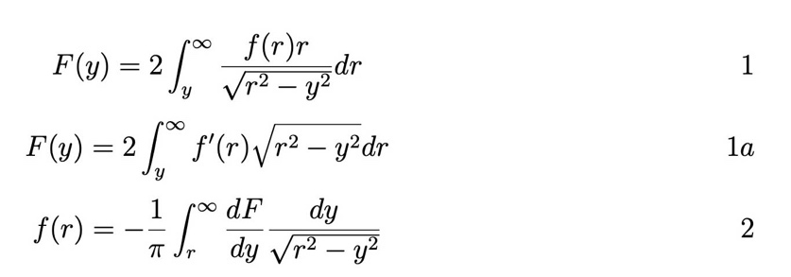

To continue with the analysis even one needs to convert the altitude dependent limb viewing measurements to altitude dependent volume emission rates. Following Hecht et al. (2015) we use an ABEL transform with a software package developed for that RAIDS data analysis. Wikipedia gives a good overview (https://en.wikipedia.org/wiki/Abel_transform) and the forward transform (eqns 1 and 1a) and inverse transform (eqn 2) are given above. Here F(y) is the integrated signal per area seen at a given tangent height y, above the center of the Earth, and f(r) is the volume emission rate. If F is in Rayleighs then the value -10f(r) is in photons/cm3/s. There are several issues with recovering f(r) from measurements of F. (1) There is a singularity when y is equal to r. (2) A derivative is involved. (3) The results at r depend on data above r. To avoid the first issue, we used a software routine (written in IDL by Dr. Paul Straus and given in the appendix) that evaluates the integral but avoids the singularity. That algorithm was used for the RAIDS project and for the study cited earlier (Hecht et al., 20105).
We also looked at other ways of evaluating eqn 2 by direct integration. This is discussed for example on the pyABEL website (https://pyabel.readthedocs.io/en/latest/readme_link.html) and in the associated paper (Hickstein et al., 2019).The discussion on the direct integration method suggests integrating the first cell that contains the singularity analytically
(see https://pyabel.readthedocs.io/en/latest/_modules/abel/direct.html#direct_transform)
and then integrating the rest by any preferred integration scheme. We also divided the first cell into 500 equally spaced areas (excluding the one with the singularity and integrated that area.
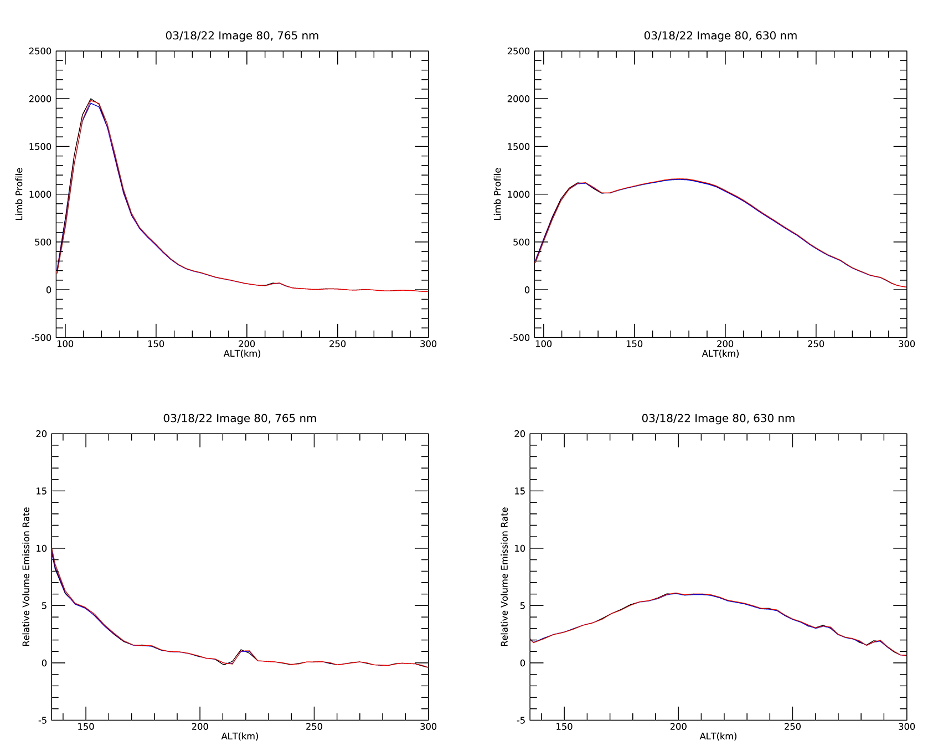Figure 6. Plots to validate the Abel Inversion Algorithms (see text)

To check the validity of all these approaches we applied the inverse transform (eqn 2) for sample measured 765 and 630 profiles and used the forward transform (eqn 1/1a) on that result to reconstruct the original limb view data. The plots in Figure 6 show the results for the sample 765 and 630 nm limb profiles (black) compared to the reconstructed limb profiles (red and blue) as well as the intermediate derived volume emission rates. For the latter we show for the region of interest (135 to 300 km). As can be seen the different methods are comparable and all reproduce the original profile. When looked at in detail the difference in the reconstructed 765 (630) profiles differ by less than 2 (1) percent or less. The 765 (630) VERs derived from the IDL code are smaller (greater) than the pyABEL method by less than ~4(~1) percent. The mean difference in the ratio is 3% with the IDL result being less than that amount.Finally, we note that to convert the above volume emission rates into units of cts/cm3/s we need to multiply by the calibrations given earlier.

7. Appendices

There are four Appendices. Note that in Appendix 4 the arrays in the ncdf and IDL saveset files are described. Many of these arrays are processed data. But note that the raw data are found for each image in the array raw_image. This array has 256 x 16 x n elements where n is the number of images in the file. Also, for convenience the two colors are extracted from the raw image and given in two arrays, cntimage_630 or cntimage_765. Each of these arrays have 59 by 16 b n elements and there are associated altitude, latitude, and longitude arrays that provide the tangent point of each observation.

Appendix 1

Appendix 1 provides the values for the plot on the left-hand side of slide 5. This found in the array, as noted in the discussion above, called raw_image that has (256,16,867) elements as these data are from raw_image (0:255,8,81) for the March 18, 2022, data found in the IDL save set or in the ncdf file.

4271.00 4866.00 5650.00 5991.00 6209.00 6201.00 5983.00 5676.00 5247.00 4988.00 4856.00 4759.00 4618.00 4545.00
4495.00 4445.00 4385.00 4392.00 4339.00 4342.00 4316.00 4302.00 4299.00 4253.00 4224.00 4242.00 4227.00 4179.00
4197.00 4262.00 4219.00 4204.00 4207.00 4201.00 4174.00 4183.00 4218.00 4161.00 4162.00 4198.00 4148.00 4160.00
4200.00 4198.00 4173.00 4206.00 4170.00 4174.00 4173.00 4186.00 4174.00 4165.00 4179.00 4135.00 4163.00 4168.00
4169.00 4195.00 4187.00 4252.00 4404.00 4543.00 4650.00 4703.00 4740.00 4765.00 4756.00 4767.00 4685.00 4597.00
4607.00 4468.00 4369.00 4336.00 4257.00 4183.00 4184.00 4186.00 4149.00 4158.00 4155.00 4152.00 4182.00 4121.00
4162.00 4127.00 4165.00 4195.00 4173.00 4163.00 4128.00 4147.00 4169.00 4142.00 4150.00 4174.00 4149.00 4154.00
4147.00 4163.00 4157.00 4143.00 4142.00 4145.00 4136.00 4205.00 4115.00 4154.00 4115.00 4148.00 4125.00 4180.00
4145.00 4154.00 4172.00 4172.00 4255.00 4131.00 4179.00 4141.00 4123.00 4150.00 4144.00 4148.00 4154.00 4160.00
4135.00 4148.00 4154.00 4153.00 4139.00 4145.00 4148.00 4173.00 4128.00 4151.00 4139.00 4152.00 4177.00 4141.00
4163.00 4149.00 4121.00 4158.00 4127.00 4161.00 4141.00 4150.00 4125.00 4148.00 4167.00 4171.00 4186.00 4160.00
4163.00 4163.00 4139.00 4135.00 4152.00 4164.00 4187.00 4159.00 4177.00 4148.00 4191.00 4187.00 4173.00 4182.00
4190.00 4174.00 4194.00 4129.00 4250.00 4177.00 4180.00 4238.00 4281.00 4218.00 4219.00 4253.00 4313.00 4223.00
4279.00 4268.00 4268.00 4278.00 4300.00 4377.00 4379.00 4560.00 4804.00 5006.00 5203.00 5404.00 5426.00 5476.00
5630.00 5550.00 5464.00 5555.00 5520.00 5526.00 5557.00 5585.00 5642.00 5625.00 5626.00 5648.00 5658.00 5648.00
5636.00 5604.00 5621.00 5612.00 5520.00 5514.00 5474.00 5445.00 5377.00 5308.00 5274.00 5223.00 5181.00 5143.00
5057.00 5038.00 5031.00 4942.00 4930.00 4867.00 4854.00 4792.00 4800.00 4720.00 4665.00 4629.00 4621.00 4655.00
4580.00 4584.00 4546.00 4477.00 4500.00 4486.00 4495.00 4477.00 4461.00 4430.00 4414.00 4421.00 4449.00 4589.00
4631.00 4662.00 4733.00 4775.00

Appendix 2

This provides the band fraction of the O2A (0,0) band that passes through the DAILI 765 filter. This was calculated for a quite time MSIS atmosphere.
Altitude. frac765
95.8503 0.163641
100.554 0.162330
105.225 0.169155
109.863 0.178460
114.468 0.182059
119.041 0.179035
123.581 0.173482
128.087 0.167759
132.561 0.162475
137.001 0.157711
141.408 0.153500
145.781 0.149809
150.121 0.146570
154.427 0.143809
158.699 0.141389
162.938 0.139254
167.142 0.137377
171.313 0.135723
175.449 0.134255
179.551 0.132967
183.619 0.131834
187.653 0.130824
191.652 0.129921
195.616 0.129113
199.546 0.128389
203.441 0.127751
207.302 0.127175
211.127 0.126653
214.918 0.126179
218.674 0.125760
222.395 0.125378
226.080 0.125031
229.731 0.124721
233.346 0.124440
236.926 0.124181
240.470 0.123944
243.979 0.123737
247.453 0.123545
250.891 0.123367
254.294 0.123209
257.661 0.123062
260.992 0.122924
264.288 0.122801
267.548 0.122691
270.772 0.122588
273.960 0.122491
277.112 0.122405
280.228 0.122327
283.309 0.122254
286.353 0.122181
289.362 0.122110
292.334 0.122040
295.270 0.121970
298.170 0.121902
301.034 0.121834
303.862 0.121767
306.653 0.121701
309.409 0.121636
312.128 0.121571

Temperature (K) profile for this atmosphere

ALTITUDE 90.0000 KM TEMPERATURE 194.800
ALTITUDE 95.0000 KM TEMPERATURE 178.400
ALTITUDE 100.000 KM TEMPERATURE 172.800
ALTITUDE 105.000 KM TEMPERATURE 190.200
ALTITUDE 110.000 KM TEMPERATURE 231.100
ALTITUDE 115.000 KM TEMPERATURE 291.500
ALTITUDE 120.000 KM TEMPERATURE 364.800
ALTITUDE 125.000 KM TEMPERATURE 426.200
ALTITUDE 130.000 KM TEMPERATURE 476.800
ALTITUDE 135.000 KM TEMPERATURE 521.700
ALTITUDE 140.000 KM TEMPERATURE 561.600
ALTITUDE 145.000 KM TEMPERATURE 597.000
ALTITUDE 150.000 KM TEMPERATURE 628.600
ALTITUDE 155.000 KM TEMPERATURE 656.500
ALTITUDE 160.000 KM TEMPERATURE 681.400
ALTITUDE 165.000 KM TEMPERATURE 703.600
ALTITUDE 170.000 KM TEMPERATURE 723.200
ALTITUDE 175.000 KM TEMPERATURE 740.700
ALTITUDE 180.000 KM TEMPERATURE 756.300
ALTITUDE 185.000 KM TEMPERATURE 770.200
ALTITUDE 190.000 KM TEMPERATURE 782.500
ALTITUDE 195.000 KM TEMPERATURE 793.400
ALTITUDE 200.000 KM TEMPERATURE 803.200
ALTITUDE 205.000 KM TEMPERATURE 811.900
ALTITUDE 210.000 KM TEMPERATURE 819.600
ALTITUDE 215.000 KM TEMPERATURE 826.500
ALTITUDE 220.000 KM TEMPERATURE 832.700
ALTITUDE 225.000 KM TEMPERATURE 838.200
ALTITUDE 230.000 KM TEMPERATURE 843.000
ALTITUDE 235.000 KM TEMPERATURE 847.400
ALTITUDE 240.000 KM TEMPERATURE 851.300
ALTITUDE 245.000 KM TEMPERATURE 854.700
ALTITUDE 250.000 KM TEMPERATURE 857.800
ALTITUDE 255.000 KM TEMPERATURE 860.500
ALTITUDE 260.000 KM TEMPERATURE 863.000
ALTITUDE 265.000 KM TEMPERATURE 865.200
ALTITUDE 270.000 KM TEMPERATURE 867.100
ALTITUDE 275.000 KM TEMPERATURE 868.900
ALTITUDE 280.000 KM TEMPERATURE 870.400

Appendix 3

This appendix provides the IDL software code used in the analysis.

FUNCTION AbelInvert, r, I
;
; Calculates the Abel inverse transform of I(r). Here r is the radius of the tangent
; altitude.
;
if (r(0) gt r(Num(r)-1)) then begin ; Put data into ascending order
r2 = reverse(r)
I2 = reverse(I)
endif $
else begin
r2 = r
I2 = I
endelse
Ip = deriv(r2, I2)

Ans = fltarr(Num(r))
for j=0, Num(r2)-2 do begin
ztan2 = r2(j:*)
Ip2 = Ip(j:*)
AvgIp = (Ip2(1:*) + Ip2)/2
Fact = ztan2 + sqrt(ztan2^2 - ztan2(0)^2)
Ans(j) = total(AvgIp*alog(Fact(1:*)/Fact))
endfor

if (r(0) gt r(Num(r)-1)) then Ans = reverse(Ans)

return, -10*Ans/!pi
END

FUNCTION Num, array
;
; Same as n_elements, but shorter!
;
return, n_elements(array)
END

FUNCTION SumJLimb, j, z, zMax
;
; Calculates the integral of a volume emission rate (j(z)) along ;the line of sight in a
; limb-viewing geometry for the first zMax elements of z
;Assumes spherical symmetry, an optically thin emission, and that j is zero
; above the maximum z-value. z (in km) must be in ascending ;order. j is in
; photons/cc/sec. Answer in rayleighs.
;
; The z/zMax convention is designed to allow for the possibility that the altitude of the
; observer is substantially above the altitude of strong ;emissions that are falling off
; expontially with altitude. In such a case the interesting altitude range of the airglow
; intensities ends below the observer altitude. However, to ;avoid errors at the top end of
; the range of interest, j(z) must be integrated to higher ;altitudes (approximately 3
; scale heights above the maximum altitude of interest
;To do this, provide j(z) over this larger altitude range and ;set zMax to the
; index of the maximum altitude of interest.
;
COMMON SUMJLIMBMEMORY, Factors, Oldz, OldzMax

if (IsArray(where((z(1:*)-z) le 0))) then begin
print, "SumJLimb: ERROR - ordering of altitude array invalid!"
stop
endif

if (IsVoid(zMax)) then zMax = Num(z) - 1

Re = 6370.0 ; Earth radius (km)

m = Num(j)
CalcFactors = IsVoid(Factors)
if (~CalcFactors) then CalcFactors = (Num(Oldz) ne Num(z)) or (OldzMax ne zMax)
if (~CalcFactors) then CalcFactors = IsArray(where(Oldz ne z))
if ( CalcFactors) then begin
Factors = fltarr(m,zMax)
for ind=0, zMax-1 do Factors(ind:*,ind) = -2*sqrt((z(ind:*)+Re)^2 - (z(ind)+Re)^2)

Oldz = z
OldzMax = zMax
endif

dj = deriv(z, j)
I = fltarr(zMax)
for ind=0, zMax-1 do begin
kernal = Factors(ind:*,ind)*dj(ind:*)
I(ind) = Integrate(z(ind:*), kernal) + 2*j(m-1)*sqrt((z(m-1)+Re)^2 - (z(ind)+Re)^2)
endfor

return, I/10.0
END

FUNCTION Integrate, x, y
;
; Integral of a function (unevenly spaced data points ok, but x can only be
; increasing).
;
return, total((y(1:*) + y(0:num(y)-2))*(x(1:*) - x(0:num(y)-2)))/2.0
END

FUNCTION Deriv, x, y
;+
; NAME:
; DERIV
;
; PURPOSE:
; Perform numerical differentiation using 3-point, Lagrangian
; interpolation.
;
; CATEGORY:
; Numerical analysis.
;
; CALLING SEQUENCE:
; Dy = Deriv(Y) ;Dy(i)/di, point spacing = 1.
; Dy = Deriv(X, Y) ;Dy/Dx, unequal point spacing.
;
; INPUTS:
; Y: Variable to be differentiated.
; X: Variable to differentiate with respect to. If omitted, unit
; spacing for Y (i.e., X(i) = i) is assumed.
;
; OPTIONAL INPUT PARAMETERS:
; As above.
;
; OUTPUTS:
; Returns the derivative.
;
; COMMON BLOCKS:
; None.
;
; SIDE EFFECTS:
; None.
;
; RESTRICTIONS:
; None.
;
; PROCEDURE:
; See Hildebrand, Introduction to Numerical Analysis, Mc Graw
; Hill, 1956. Page 82.
;
; MODIFICATION HISTORY:
; Written, DMS, Aug, 1984.
; Modified to handle unevenly spaced points correctly, PRS, Nov, 1999.
;-
;
on_error,2 ;Return to caller if an error occurs
n = Num(x)
if (n lt 3) then message, 'Parameters must have at least 3 points'

if (n_params(0) ge 2) then begin
if (n ne Num(y)) then message,'Vectors must have same size'
; d = float(shift(y,-1) - shift(y,1))/(shift(x,-1) - shift(x,1)) ;
; d[0] = (-3.0*y[0] + 4.0*y[1] - y[2])/(x[2]-x[0]) ; Old code
; d[n-1] = (3.*y[n-1] - 4.*y[n-2] + y[n-3])/(x[n-1]-x[n-3]) ;
x0 = shift(x,-1)
x2 = shift(x, 1)
y0 = shift(y,-1)
y2 = shift(y, 1)
d = float(y0*(x-x2))/((x0-x )*(x0-x2)) + y*(1.0/(x-x0) + 1.0/(x-x2)) + $
float(y2*(x-x0))/((x2-x0)*(x2-x ))
d[ 0 ] = y[0]*(1.0/(x[0]-x[2]) + 1.0/(x[0]-x[1])) + $
float(y[1]*(x[0]-x[2]))/((x[1]-x[0])*(x[1]-x[2])) + $
float(y[2]*(x[0]-x[1]))/((x[2]-x[0])*(x[2]-x[1]))

d[n-1] = float(y[n-3]*(x[n-1]-x[n-2]))/((x[n-3]-x[n-2])*(x[n-3]-x[n-1])) + $
float(y[n-2]*(x[n-1]-x[n-3]))/((x[n-2]-x[n-3])*(x[n-2]-x[n-1])) + $
y[n-1]*(1.0/(x[n-1]-x[n-3]) + 1.0/(x[n-1]-x[n-2]))
end $
else begin
d = (shift(x,-1) - shift(x,1))/2.
d[ 0 ] = (-3.0*x[ 0 ] + 4.0*x[ 1 ] - x[ 2 ])/2.
d[n-1] = ( 3.0*x[n-1] - 4.0*x[n-2] + x[n-3])/2.
endelse

return, d
END

FUNCTION IsVoid, x
return, (n_elements(x) eq 0)
END

FUNCTION IsArray, x
return, ((size(x))(0) ge 1)
END

Appendix 4

This Appendix provides the titles for the data stored in idl save sets at zenodo.
Appendix 5 repeats most of these for the ncdf files

This provides an annotated list of the arrays contained in the save set or nc files. Note that the examples data as listed are from March 18, 2022 and where specified file image 80, where image 0 is the first image. The annotations in red help explain the data names.

TITLE STRING 'DAILI_MAIN_L1_OUTPUTFILE'
MISSION STRING 'DAILI'
DATA_PRODUCT_TYPE
STRING 'LEVEL 1'
DATA_SOURCE STRING 'DAILI MOC'
SOFTWARE_VERSION
STRING 'DAILI_MAIN_VERSION = 4.10000'
INPUT_SOFTWARE_NAME
STRING './LEVEL01A'

ORBIT_FILENAME STRING 'L0_DAILI_Mar_18_2022_02-28-25_final_tag_2022-03-18_V9.sav'
DATE_GENERATED STRING 'Thu Jan 26 18:30:09 2023'
DATA_START_TIME STRING 'Fri Mar 18 02:28:25 2022'
DATA_END_TIME STRING 'Fri Mar 18 23:59:55 2022'
ORBIT_NUMBER STRING 'TBD'

EXPOSURES_TOTAL LONG 867

INDICES_OF_PROCESSED_DAYSIDE_IMAGES;The first 5 are 57,58,59,60,61.
LONG Array[259]
NUMBER_DAYTIME_IMAGES_PROCESSED
LONG 233
NUMBER_NIGHTSIDE_IMAGES
LONG 461
NUMBER_TWILIGHT_IMAGES
LONG 173
PROCESSED_IMAGES_THIS_FILE
STRING 'DAYSIDE PROCESSING FROM IMAGE NUMBER 68 TO 846'

INDICES_OF_DAYSIDE_IMAGES;The first five are 68,69,70,71,72
LONG Array[233]
INDICES_OF_NIGHTSIDE_IMAGES
LONG Array[461];The first five are 0,1,2,3,4
INDICES_OF_TWILIGHT_IMAGES
LONG Array[173];The first five are 45,46,47,48,49
INDICES_OF_GOOD_POINTING
LONG 867

FLAG INT Array[2, 867]
FLAG_INFO STRING 'VALUE IN OTH COLUMN IS 0=DAYSIDE, 1= TWILIGHT, 2 = NIGHTSIDE.VALUE IN 1ST COLUMN IS POINTING WITH 0 = OK, 1 = QUESTIONABLE'. ;flag(*,80)= 0 0

MONTH STRING Array[867]; month(80)=03
DAY STRING Array[867]; day(80)=18
YEAR STRING '2022'
DATE STRING Array[867];date(80)=2022077
DATE_UNITS STRING 'YYYYDDD'

L0_INPUT_SOFTWARE_NAME
STRING 'L0_DAILI_Mar_18_2022_02-28-25_final_tag_2022-03-18_V8.sav'

L1_SOFTWARE_VERSION
LONG 4
L1_SOFTWARE_NAME
STRING 'DAILI_MAIN.PRO'

MODE INT Array[867] ;Not Defined

TIME_UT (s) DOUBLE Array[867] ;time_ut(80) 11335.011 s
at beginning of collect
TIME_UT_MISSING_VALUE
FLOAT -999.000
TIME_UTEND DOUBLE Array[867];time_utend(80)=11340.011
;end of collect
TIME_UTEND_MISSING_VALUE
FLOAT -999.000
TPDN INT Array[867] ;tpdn(80)=0 TPDN identifies an image as daytime(0), twilight(1) or night(2)

DWELL INT Array[867];dwell(80)=5
DWELL_LONG_NAME STRING 'Seconds, accumulation period'

IMAGECOR_630 FLOAT Array[59, 16,867];
imagecor_630(*,8,80)=1491.00 For the 630 data a constant value of 4000 is subtracted from the raw counts
IMAGECOR_630_LONG_NAME
STRING 'Superpixel counts (ADUs) per dwell period for each superpixel vertical (59) and horizontal (16) in the 6300 A channel'
RAY_IMAGECOR_630
FLOAT Array[59, 16, 867]; ray_imagecor_630(9,8,80)=imagecor_630 times the cal (R/ADU)
RAY_IMAGECOR_630_LONG_NAME
STRING 'Fully corrected image in Rayleighs'-
RAY_IMAGECOR_630_MISSING_VALUE
STRING '-999.000 '

IMAGECOR_765 FLOAT Array[59, 16, 867]
IMAGECOR_765_LONG_NAME
STRING 'Superpixel counts per dwell period for each superpixel IN 765'
IMAGECOR_765_MISSING_VALUE
STRING '-999.000'
RAY_IMAGECOR_765
FLOAT Array[59, 16, 867]
RAY_IMAGECOR_765_LONG_NAME
STRING 'Image after dark count, scattered light correction and responsivity calibration, Imagecor_765 times cal(R/ADU)/bandfrac(given in Appendix)'
RAY_IMAGECOR_765_MISSING_VALUE
STRING '-999.000'

AVG_630 FLOAT Array[59, 4, 867] ;avg_630(9,2,80)=65210.2
AVG_630_LONG_NAME
STRING 'BRIGHTNESS IN RAYLEIGHS, AVERAGE OF 3 CONTIGUOUS ALTITUDE PROFILES'
;The 16 vertical profiles are divided into superpixels as follows:(0)is 3,4,5,(1)is 6,7,8,(2) is 9,10,11,(3)is 12,13,14.
AVG_630_MISSING_VALUE
STRING '-999.000'
AVG_765 FLOAT Array[59, 4, 867]
;avg_765(9,2,80)=127338.
AVG_765_LONG_NAME
STRING 'BRIGHTNESS IN RAYLEIGHS, AVERAGE OF 3 CONTIGUOUS PROFILES'
AVG_765_MISSING_VALUE
STRING '-999.000'

FINVER_630 FLOAT Array[59, 4, 867]
finver_630(9,2,80)=101.220

FINVER_630_LONG_NAME
STRING 'FINAL 630 VOLUME EMISSION RATE ALTITUDE PROFILE - CM-3S-1'

FINVER_630_MISSING_VALUE
STRING '-999.000'

FINVER_765 FLOAT Array[59, 4, 867]
finver_765(9,2,80)= 1344.90
FINVER_765_LONG_NAME
STRING 'FINAL 765 VOLUME EMISSION RATE ALTITUDE PROFILE - CM-3S-1'
FINVER_765_MISSING_VALUE
STRING '-999.000'

RATIO FLOAT Array[59, 4, 867]
ratio(9,2,80)=13.2870
RATIO_LONG_NAME STRING 'Ratio of volume emission rates ALTITUDE PROFILE (FINVER_765/FINVER_630)'
RATIO_MISSING_VALUE
STRING '-999.000'

O2D_RESULT FLOAT Array[59, 4, 867]
o2d_result(9,2,80)=7.30657e+09
O2D_RESULT_LONG_NAME
STRING 'Derived O2 density profile from RATIO'; and using the conversion following Hecht et al.,[2015] and the constants given below
O2D_RESULT_MISSING_VALUE
STRING '-999.000'

O2D_AURIC FLOAT Array[100]
o2d_auric(44)=5.69500e+09 value from a quiet day auric model O2D_AURIC_LONG_NAME
STRING 'AURIC MODEL O2 DENSITY '
AURIC_ALT_DEN FLOAT Array[100]
auric_alt_den(44)=137.710
AURIC_ALT_DEN_LONG_NAME
STRING 'ALTITUDE ARRAY (km) FOR O2D_AURIC'

TPALTITUDE FLOAT Array[59, 16, 867]
tpaltitude(9,8,80)=136.814
TPALTITUDE_LONG_NAME
STRING 'Tangent Point Altitude of LOS in km'
TPALTITUDE_MISSING_VALUE
STRING '-999.000'
TPLATITUDE FLOAT Array[59, 16, 867]
tplatitude(9,8,80)=-50.0433
TPLATITUDE_LONG_NAME
STRING 'Tangent Point Latitude'
TPLATITUDE_MISSING_VALUE
FLOAT -999.000
TPLONGITUDE FLOAT Array[59, 16, 867]
tplongitude(9,8,80)=3.1192
TPLONGITUDE_LONG_NAME
STRING 'Tangent Point longitude'
TPLONGITUDE_MISSING_VALUE
FLOAT -999.000
TPSOLARZEN FLOAT Array[59, 16, 867]
tpsolarzen(9,8,80)=60.4724
TPSOLARZEN_LONG_NAME
STRING 'Tangent Point Solar zenith angle'
TPSOLARZEN_MISSING_VALUE
FLOAT -999.000
TPSOLARLT FLOAT Array[59, 16, 867]
tpsolarlt(9,8,80)= 9.35656
TPSOLARLT_LONG_NAME
STRING 'Tangent Point Solar Local Time'
TPSOLARLT_MISSING_VALUE
FLOAT -999.000
SCALTITUDE DOUBLE Array[867]
sclatitude(80)=-51.652682
SCALTITUDE_LONG_NAME
STRING 'Spacecraft altitude in km'
SCALTITUDE_MISSING_VALUE
FLOAT -999.000
SCLONGITUDE DOUBLE Array[867]
sclongitude(80)=119.07874
SCLONGITUDE_LONG_NAME
STRING 'Spacecraft longitude in degrees'
SCLONGITUDE_MISSING_VALUE
FLOAT -999.000
INSTRUMENT_STATUS
STRING Array[867];Not Used in this version

CNTIMAGE_630 FLOAT Array[59, 16, 867]
cntimage_630(9,8,80)=5491.00
CNTIMAGE_630_MISSING_VALUE
FLOAT -999.000
CNTIMAGE_630_LONG_NAME
STRING ' raw Super pixel cnt/dwell before any
dark subtraction'

CNTIMAGE_765 FLOAT Array[59, 16, 867]
cntimage_765(9,8,80)=4988.00
CNTIMAGE_765_LONG_NAME
STRING 'raw Super Pixel cnt/dwell before any dark subtraction'
CNTIMAGE_765_MISSING_VALUE
FLOAT -999.000

RAW_IMAGE INT Array[256, 16, 867]; see Appendix 1
RAW_IMAGE_LONG_NAME
STRING 'Full image cnt/dwell'
RAW_IMAGE_MISSING_VALUE
FLOAT. -999.000

MOONSEPANGLE DOUBLE Array[867]
moonsepangle(80)=62.456960
MOONSEPANGLE_LONG_NAME
STRING 'Angles between the Moon and the LOS in degrees'
SUNLOSANGLE DOUBLE Array[867]
SUNLOSANGLE_LONG_NAME
STRING 'Angle between Sun and LOS in degrees'
SUNLOSANGLE_MISSING_VALUE
FLOAT -999.000

; following are constants needed to turn the ratio into O2D see Hecht et al (2015).GRL paper and references therein
A630 FLOAT 0.00910000
A630_LONG_NAME STRING 'EINSTEIN COEFF FOR O1D EMISSION'
TEMP. FLOAT 600.000
TEMP_LONG_NAME STRING 'TEMPERATURE USED IN MOLECULARA OXYGEN CALCULATION'
KAPPA FLOAT 3.61680e-11
KAPPA_LONG_NAME STRING 'KAPPA VALUE O2 + O1D REACTION RATE'
BETA1 FLOAT 0.800000
BETA1_LONG_NAME STRING 'EFFICIENCY OF PRODUCTING SINGLET SIGMA STATE OF O2'
F0 FLOAT 0.600000
F0_LONG_NAME STRING ' EFFIENCIES OF POPULATING THE V=0 OR 1 STATE'
F1 FLOAT 0.400000
F1_LONG_NAME STRING 'EFFIENCIES OF POPULATING THE V=0 OR 1 STATE'
AV FLOAT 0.0919000
AV_LONG_NAME STRING 'EINSTEIN COEFF FOR EMISSION OF UPPER V STATE'
A00 FLOAT 0.0876000
A00_LONG_NAME STRING 'EINSTEIN COEFF FOR RADIATING IN 0-0 TRANSITION'
A11_LONG_NAME STRING 'EINSTEIN COEFF FOR RADIATION IN 1-1 TRANSITION'
A11 FLOAT 0.0700000

APPENDIX 5
Header information for ncdf files
Appendix 4 provides a more extensive list than we saved for the ncdf files. Refer to that list for the definitions. Below we refer to March 13,2022 where there were 689 files. For March,18,2022 there are 867 files and examples of the data are in Appendix 4

MONTH INT Array[689]
DAY INT Array[689]
YEAR INT Array[689]
DATE LONG Array[689]
MODE INT Array[689]
TIME_UT FLOAT Array[689]
TIME_UT_END FLOAT Array[689]
DWELL INT Array[689]
CNTIMAGE_630 FLOAT Array[59, 16, 689]
CNTIMAGE_765 FLOAT Array[59, 16, 689]
RAW_IMAGE FLOAT Array[256, 16, 689]
; Next two are redundent as they are the same as raw image
; They were not in the IDL save set
DAILI_RAW_630 FLOAT Array[256, 16, 689]
DAILI_RAW_765 FLOAT Array[256, 16, 689]
;
INDICES_OF_DAYSIDE_PROCESSED_IMAGES
INT Array[689]
INDICES_OF_NIGHTSIDE_IMAGES
INT Array[689]
INDICES_OF_TWILIGHT_IMAGES
INT Array[689]

INDICES_OF_GOOD_POINTING
INT Array[689]
FLAG INT Array[2, 689]
IMAGECOR_630 FLOAT Array[59, 16, 689]
IMAGECOR_765 FLOAT Array[59, 16, 689]
RAY_IMAGECOR_630
FLOAT Array[59, 16, 689]
RAY_IMAGECOR_765
FLOAT Array[59, 16, 689]
AVG_630 FLOAT Array[59, 4, 689]
AVG_765 FLOAT Array[59, 4, 689]
FINVER_630 FLOAT Array[59, 4, 689]
FINVER_765 FLOAT Array[59, 4, 689]
RATIO FLOAT Array[59, 4, 689]
O2D_RESULT FLOAT Array[59, 4, 689]
TPALTITUDE FLOAT Array[59, 16, 689]
TPALTITUDEEND FLOAT Array[59, 16, 689]
TPLATITUDE FLOAT Array[59, 16, 689]
TPLONGITUDE FLOAT Array[59, 16, 689]
TPSOLARZEN FLOAT Array[59, 16, 689]
TPSOLARLT FLOAT Array[59, 16, 689]
SCALTITUDE FLOAT Array[689]
SCLATITUDE FLOAT Array[689]
SCLONGITUDE FLOAT Array[689]
SCSOLARZEN FLOAT Array[689]
MOONSEPANGLE FLOAT Array[689]
SUNLOSANGLE FLOAT Array[689]
EARTH_SUN FLOAT 1.49500e+08
A630 FLOAT 0.00910000
TEMP FLOAT 600.000
KAPPA FLOAT 3.61680e-11
BETA1 FLOAT 0.800000
F0 FLOAT 0.600000
F1 FLOAT 0.400000
AV FLOAT 0.0919000
A00 FLOAT 0.0876000
A11 FLOAT 0.0700000
TPDN INT Array[689]

8. References

Hecht, J. H., Christensen, A. B., Yee, J.-H., Crowley, G., Bishop, R. L., Budzien, S. A., Stephan, A. W., and Evans, J. S. (2015), A new technique for remote sensing of O₂ density from 140 to 180 km, Geophys. Res. Lett., 42, 233– 240, doi:10.1002/2014GL062355.

Hickstein, Daniel, D., Stephen T. Gibson, Roman Yurchak, Dhrubajyoti D. Das, Mikhail Ryazanov, A direct comparison of high-speed methods for the numerical Abel transform,
Rev Sci Instrum 90, 065115 (2019) https://doi.org/10.1063/1.5092635

