Guide to SSUSI DATA Products

The following guide provides a brief description of the different data products made by the SSUSI Ground Data Analysis System. We begin with a table that summarizes the SSUSI data products and their CalVal status. This table is followed by a little more in depth description of the products.

Data Product | Parameters Extracted from SSUSI Sensor Data – and CalVal status | Use | Section
SDRs | - 2-d instrument 5 color radiances binned onto multiple grid resolutions on disk and limb; multiple altitudes for all disk grids – CalVal approved radiances | Pictoral summary views of space weather as it happens. | 1
Auroral EDRs | - Auroral boundary (poleward boundary of the auroral region, both global fit, and pixel by pixel mapping) – CalVal approved for use  - Q (energy flux)/E₀ (mean electron energy) – CalVal recommends correcting for ions (mainly protons)  - NmE, HmE – CalVal recommends correcting for ions (mainly protons), HmE looks good.  - hemispheric power, regions of proton precipitation – not part of CalVal | Polar navigation, polar  communication and radar clutter identification | Error: Reference source not found
GAIM – EDRS | - GAIM gridded radiances, mutual neutralization subtracted radiances. – CalVal recommended for use after mutual neutralization subtraction, however, MN subtraction not evaluated during CalVal | Radiances ingested into GAIM provide global coverage of data to improve ionospheric forecasts | 3
Night Limb EDRs | - NmF2 – CalVal approved for use  - HmF2 - Not performing well  - Intermediate products for fitting electron profiles: EDP (electron densities as a function of altitude), VER (Volume Emission Rate), and Htop (topside atmospheric scale height) - not specifically validated, but are used to generate a validated product | Electron density specification for communication and signal propagation | 4
Day-Limb EDRs | - Electron Density Profiles (NmF2, HmF2) – CalVal rated as poor  - Total Electron Content (TEC) – CalVal rated as poor  - Neutral densities (O₂,O, N₂) – CalVal rated as poor  - Topside Electron Densities – not validated | Neutral densities important for atmospheric drag calculation, electron densities good for ionospheric specification | 5
Night Disk EDRs | - Electon Density Profile information:  - 2-d NmF2 (&F₀F2) – CalVal approved for operational use  - HmF2 – CalVal rated fair in F16 CalVal | Electron density specification for communication and signal propagation | 6
Day Disk EDRs | - Electron Density Profile information (NmF2, HmF2) – CalVal rated poor  - Proxy for Solar Extreme UltraViolet emission (Qeuv) – CalVal rated good  - Oxygen to Nitrogen ratio (O/N2), an indicator of geomagnetic storm activity – CalVal rated good  - Total Electron Content (TEC) – CalVal rated poor. It was consistently too high (we think we know why). | Storm time condition alerts from O/N2, solar EUV flux indicator for strength of ionizing radiation, electron densities for communication | 7
Ionosphere 3D | 3D electron density “data cube” electron densities on a longitude, latitude, altitude grid; properties of any detected bubbles: centroid location, median density, volume, depth, orientation | Ray tracing of HF communications for signal path specification, maximum usable frequency determination, and detailed knowledge of GPS scintallation areas, OTH radar views | 8
KMZ | Google Earth Image files for the SSUSI SDR and EDR products. – not part of CalVal | Easy visualization of space weather | 9

SSUSI SDRs
SSUSI SDR products contain measured fluxes of ultraviolet light binned onto several uniform grids at different altitudes and resolutions. There are also observations of the Earth’s disk and limb (atmosphere layer at the Earth’s horizon). The SSUSI instrument is capable of measuring complete spectra, but to meet telemetry rate requirements, the radiances are reported in 5 bandpasses centered on the emission lines of upper atmosphere constituents:
- 121.6 nm – the Lyman alpha line of Hydrogen – this is an important background to control for SSUSI. It is also useful for sensing the proton induced component of Auroral emissions.
- 130.4 nm – an Oxygen line. An important background on the nightside.
- 135.6 nm – the oxygen line that is relateable to electron density on the nightside and and at high altitudes on the dayside.
- LBH S – The Shorter wavelength Lyman-Birge-Hopfield band of molecular nitrogen – used for determining the O/N₂ ratio that changes with geomagnetic activity.
- LBH L – The Longer wavelength Lyman-Birge-Hopfield band of molecular nitrogren – important for deriving auroral definition – can also be used for O/N₂ determination

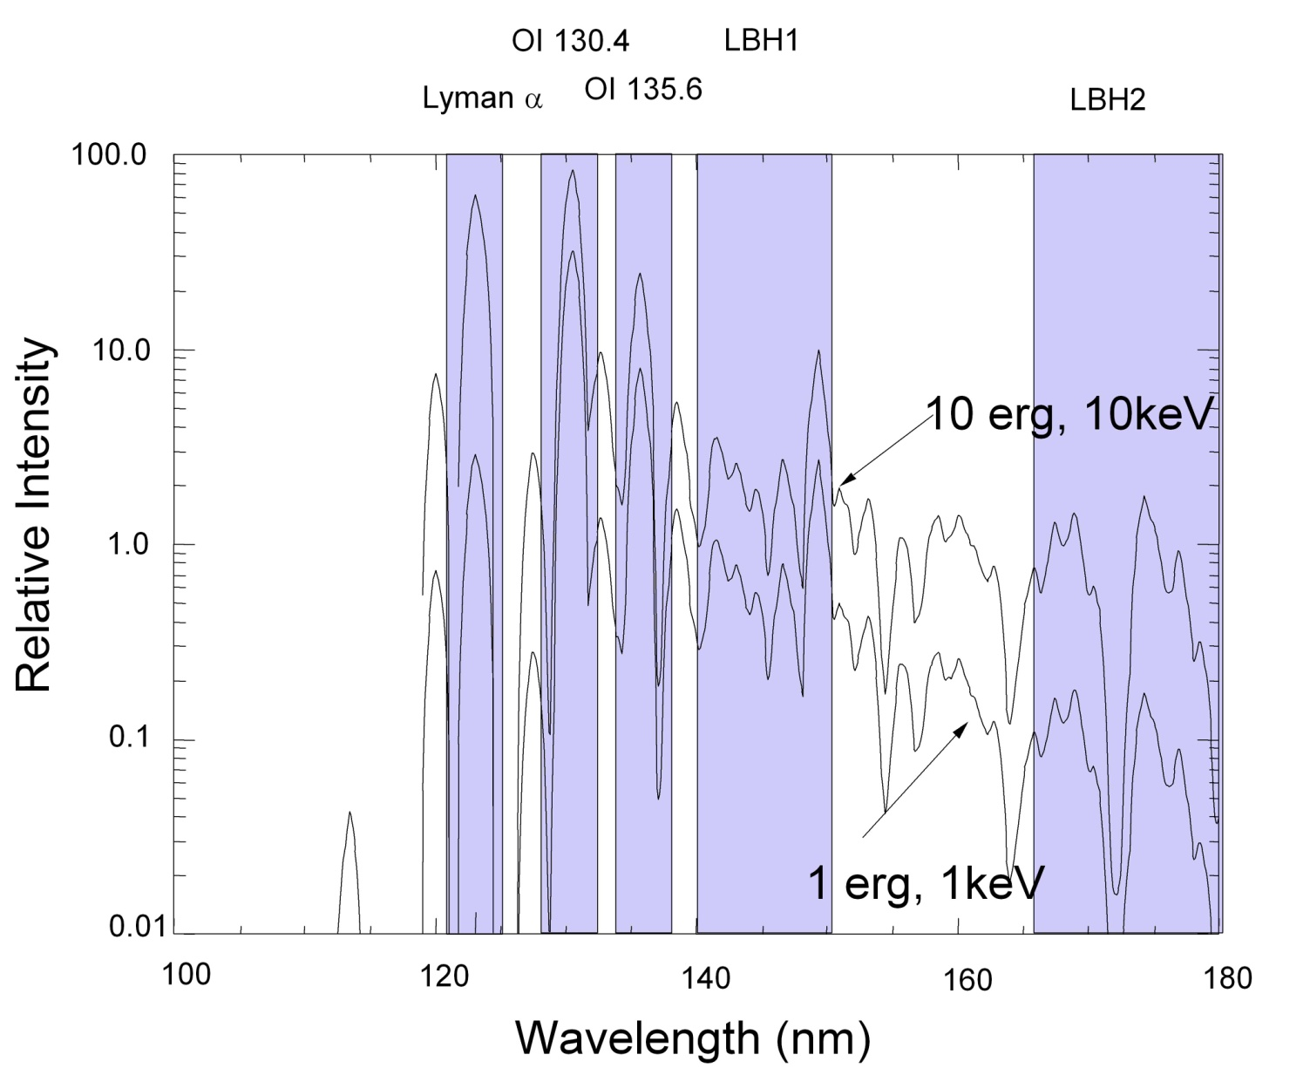
Figure 1-1 The SSUSI Radiance Color Definitions (bluish bands) are based on emissions of Oxygen, Nitrogen and Hydrogen.

There are 3 kinds of SSUSI SDR products: SDR-DISK, SDR2-DISK, and SDR-LIMB. These are described below. The UV instruments are looking at layers in the atmosphere and not looking at solid ground. That means some assumptions must be made when geolocating the radiances. On the limb, the radiances are geolocated at “tangent altitudes”, basically where the instrument line of sight reaches its lowest altitude. On the disk, we must choose a reference altitude to define a shell above the earth. Imagine a shell around the Earth at a fixed altitude above the ground. Disk geolocations are done where the instrument line of sight pierces the shell (the piercepoint). On the disk, different reference altitude grids (aurora=110 km, day=150 km, night=350 km) are defined everywhere and it is up to the user or algorithm to choose which reference altitude to use.
Disk SDR radiances have been validated in GAIM validation studies.

SDR-Disk
This product is the highest resolution disk sdr with pixels typically of size 25 km (along track) by 50 km (across track). The primary use is for auroral visualization. There are auroral, day, and night reference altitude versions of the grid. The usual filters for using these grids are
- The auroral grid is for polar auroral phenomena and is filtered on latitude (especially magnetic latitude).
- The day grid is for dayside processes and is usually filtered for solar zenith angle < 90 degrees (the boundary between day and night)
- The night grid is for nightside electron density profiles and is filtered for solar zenith angle > 100 or 110 degrees.

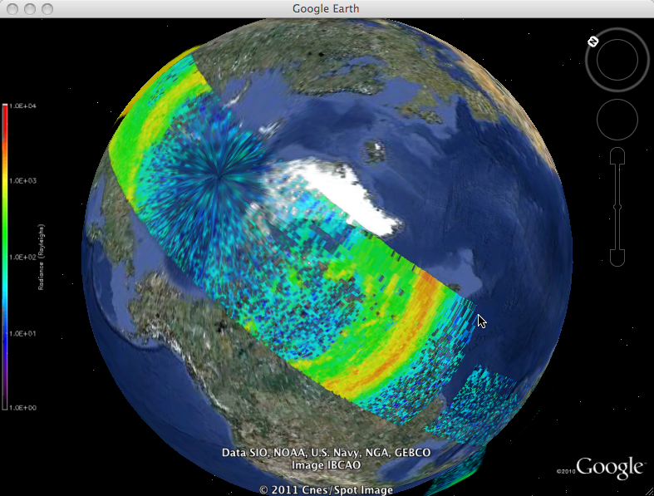
Figure 1-2 SDR-Disk visualization showing an aurora from F16 on Jan 18, 2005. This is the finest SDR disk resolution

SDR2-Disk
This product contains two different resolution versions of the three different altitude grids for a total of 6 different radiance grids. The different altitudes are usually filtered the same way as for the SDR-DISK product above. The two resolutions have pixels typically of size EDR- grid (100 km x 200 km) and GAIM – grid (300 km x 600 km).

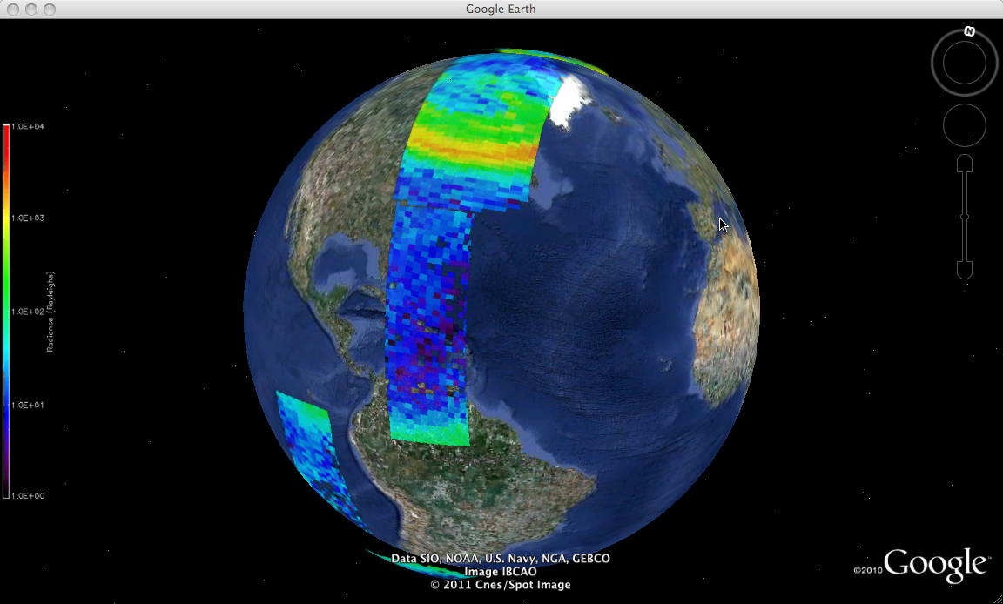 | SDR2-Disk EDR resolution Grid. In the SSUSI KMZ, the altitude reference grids are chosen for the appropriate conditions. The Auroral grid, being closer to the ground is wider than the night altitude grid.
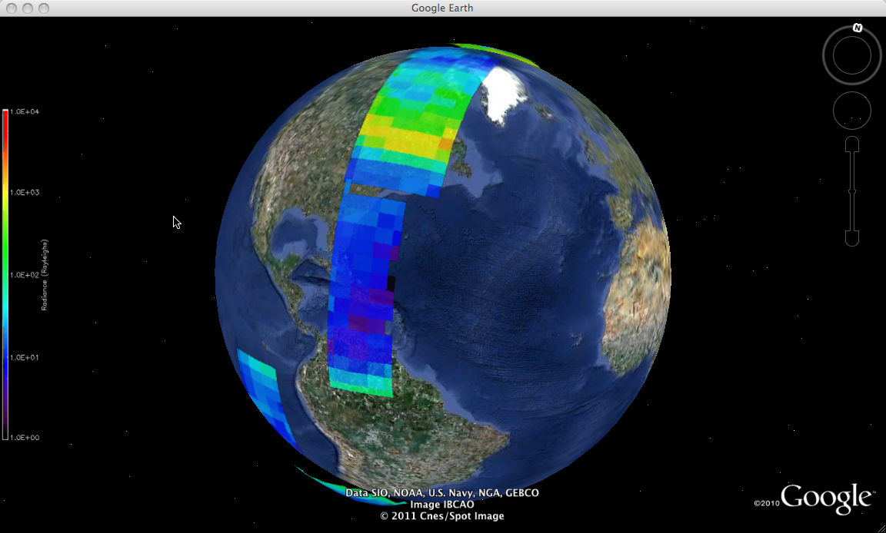 | The GAIM grid is much coarser resolution, and are consequently less noisy. These pixels are used in the GAIM model.
Figure 1-3 SDR-Disk visualization the EDR (medium) and GAIM (coarse) resolution Disk SDRs.

SDR-LIMB
The grids in the SDR-Limb are of size 20 km in altitude, and two different sizes in along track length: 100 km for EDR pixels and 300 km for GAIM pixels. Note that the altitude reported in the files is determined by the average altitude of the instrument resolution pixels contained in each bin.

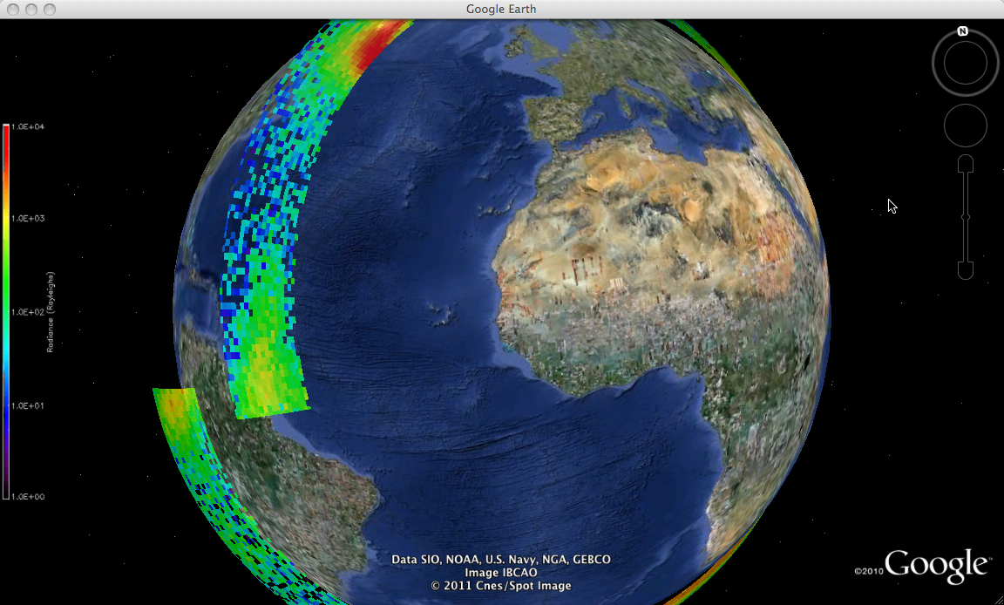 | Limb EDR grids are used in the Day and night limb algorithms.
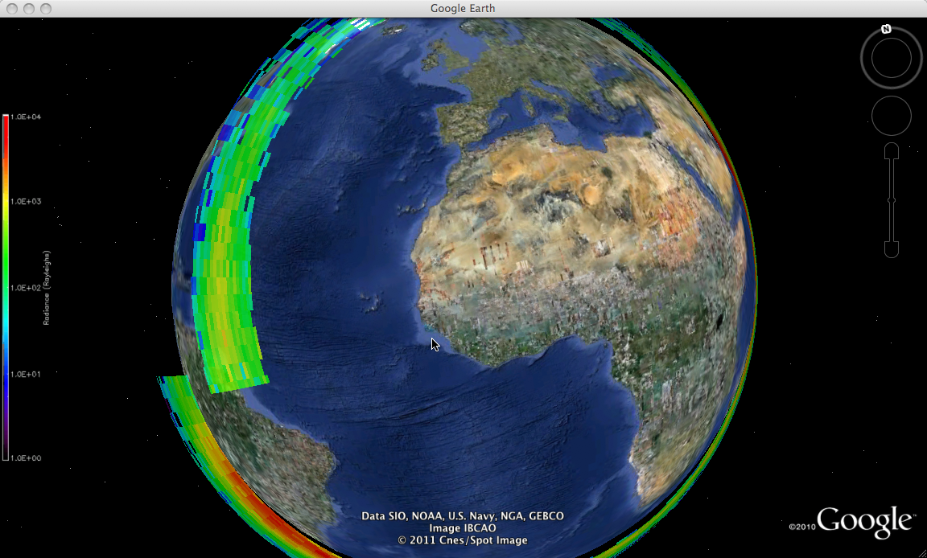 | The GAIM grid is coarse and ingested directly by GAIM.
Figure 1-4 SDR-Disk visualization the EDR (medium) and GAIM (coarse) resolution limb SDRs.

Auroral EDRs

The SSUSI auroral EDR products include (1) maps for the energy flux (Q) and mean energy (Eo) of precipitating electrons in the magnetic latitude and local time coordinates, (2) maps of peak electron density (NmE) and height (HmE) in auroral E-region ionosphere in the same coordinates, (3) equatorward auroral swath boundary within SSUSI image swath and global boundary based on an auroral model and the swath boundary in both magnetic and geographic coordinates, (4) auroral hemispheric power (HP) (the total energy flux of precipitating electrons in one hemisphere), (5) maps of the proton precipitating auroral locations. The first three products have been validated through SSUSI calibration and validation program. The hemispheric power and proton auroral map have not been validated yet. Location of auroral oval (boundaries) and auroral hemispheric power represent the magnitude of auroral activities that can significantly disturb the thermosphere and ionosphere and cause space weather effects.

Examples of the electron energy flux map, equatorward boundaries, and peak auroral E-region electron density (NmE) are shown below.

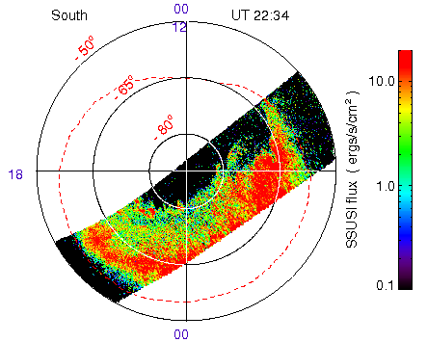 | Energy flux (Q) map of precipitating electrons in the auroral oval.

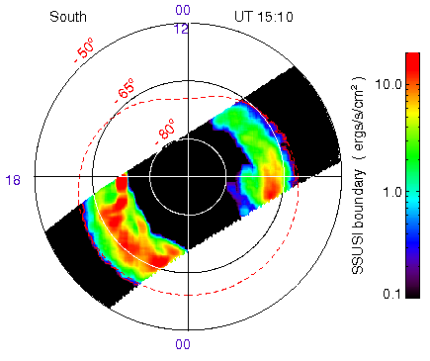 | SSUSI swath (red line) and global (red dashed line) auroral boundaries. The swath boundary traces the irregularities in the auroral edge.
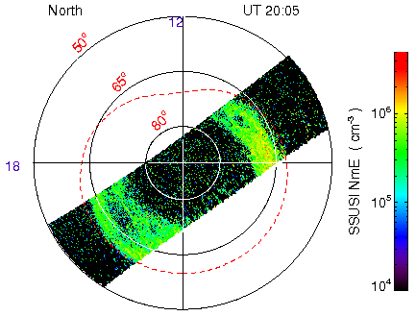 | Peak electron density (NmE) in the auroral E-region ionosphere.
Figure 2-5 Geomagnetic polar projection maps of auroral environmental parameters.

GAIM EDRs
GAIM EDRS contain the radiances that are in the GAIM grids in the SDR2-DISK and SDR-LIMB. They have additional information: 135.6 nm radiances (and errors) where the Mutual Neutralization component has been subtracted, so that the remaining radiance reflects exclusively the electron density. Additional flags and products will likely be added in the future as the GAIM full physics model is developed.

Night Limb EDRs
This product contains electron density profiles from the SSUSI SDR-LIMB data. This includes electron densities at a variety of altitudes as well as the values of NmF2 and HmF2. This algorithm includes the effect of the mutual neutralization. This algorithm was the “alternate limb algorithm” recommended in the F16 CalVal report and was validated during the F18 CalVal.

The algorithm works by first deriving Volume Emission Rates (VER) of the atmosphere, and then deducing the electron density from the VER. The algorithm must also fit an atmospheric topside scale height, H_{top}. Both the VER and H_{top} are included in the night limb EDR.

Day Limb EDRs
A recent addition to the dayside limb EDRs has been the retrieval of the high altitude (> 400 km) topside electron densities. This algorithm works in regions where the electron density is high (the equatorial arcs). In late summer of 2011, the ionosphere was hot enough to generate radiances hot enough to derive sensible electron densities. This algorithm was not able to be validated in the F18 CalVal.

The main algorithm in this product is the original 1990’s era version of a Neutral Density and electron density profile lookup algorithm. This algorithm uses lookup tables generated from models to retrieve density profiles and TEC values.

Night Disk EDRs
This product uses ionosphere model adjusted coefficients for retrieval of nightside electron densities. In particular is retrieves NmF2 on the disk. It also can retrieve HmF2 values at nadir by using the 630 and 629 nm photometer radiances. This algorithm was validated during the F16 CalVal (when the “CalVal corrected” density fields are used). However, in the F18 CalVal, the F18 data did not match the ground truth.

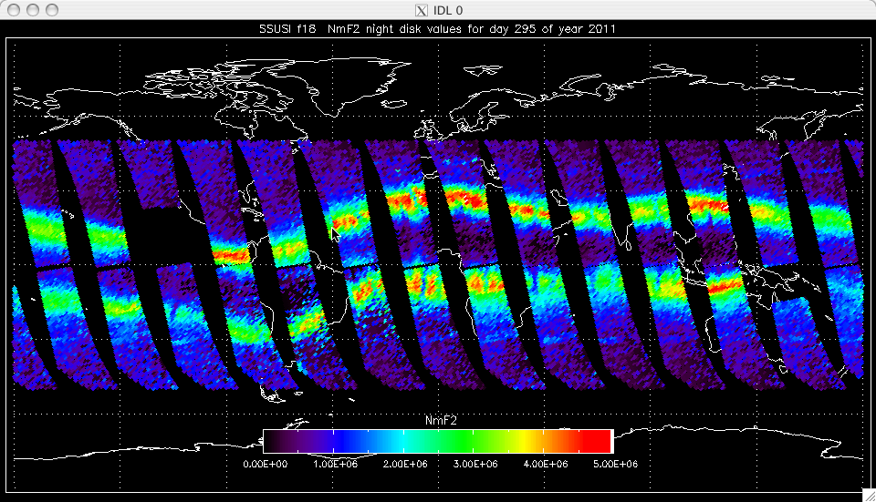 | F18 Nightside Disk NmF2 from the Nightside Disk EDRs for a whole day (2011:295). The equatorial arcs contain bubble structures seen in the retrieved densities.
Figure 6-6 EDR-Night-Disk summary visualization of NmF2.

Day Disk EDRs
Dayside disk EDRs begin by retrieving Qeuv, the integrated solar Extreme UltraViolet emission flux, and O/N₂ monatomic Oxygen to molecular Nitrogen, an indicator of geomagnetic storm conditions (see figure).

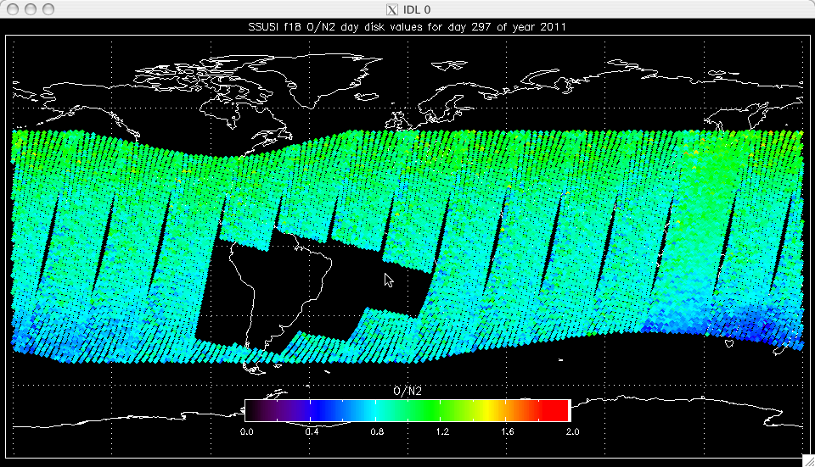 | The SSUSI O/N2 ratio on the dayside disk. As a large geomagnetic storm began to take place on Oct 24, 2011 the O/N2 ratio began to deplete in the south pacific.
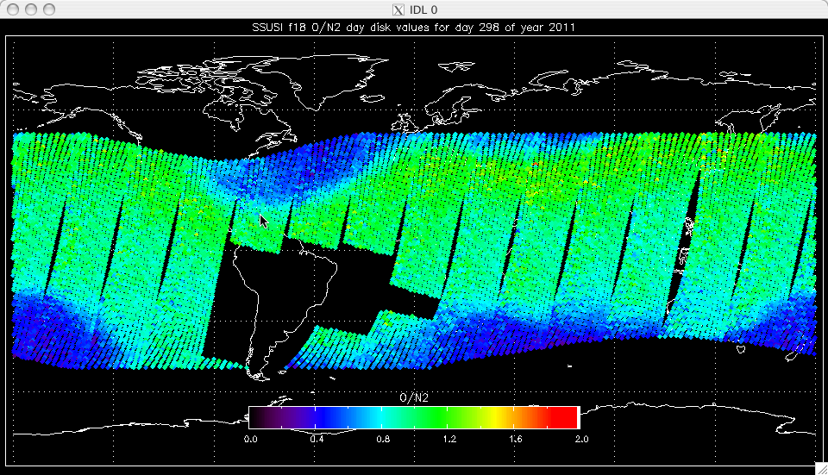 | As the storm got underway on Oct 25, 2011, the O/N2 ratio showed additional depletions in northern and southern hemispheres, as is typical of large geomagnetic storms.
Figure 7-7 EDR-Day-Disk summary visualization showing storm time changes in O/N₂ ratio.

The dayside disk algorithm also retrieves electron density profile information in the form of the parameters for NmF2, HmF2, and TEC.

Ionosphere 3D EDRs
In this product, a tomographic inversion is performed for each altitude vs. longitude slice of SSUSI 135.6 nm radiance data. For each cross-track scan, a 2-D slice is reconstructed from a moving window of 11 scans of data centered on the current cross-track scan. The 2-D slices are then combined to form a three-dimensional profile. The output is a data cube, where each point (lat, lon, alt) has an associated electron density. The resolution is: 1.2° latitude, 33 km longitude, and 20 km altitude. This data cube can be used to determine HF signal propagation with ray tracing from a signal source aimed in a particular direction. The background density is characterized by finding the latitude of the peak electron density in the equatorial arcs as well as NmF2 and HmF2.
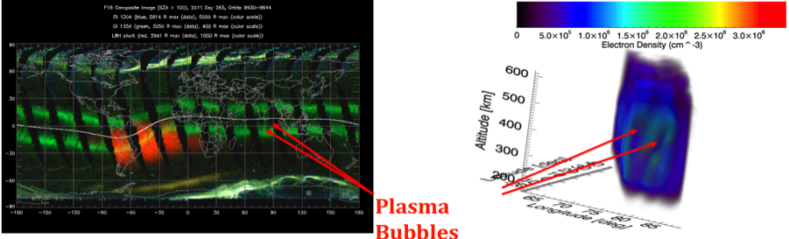
Ionospheric Bubbles, seen in SSUSI images, are identified in detail in the 3-D ionsophere data cubes.
Figure 9-8 Illustration of Ionospheric Bubbles and the 3D Ionosphere.

Depleted regions (bubbles) are identified and characterized more completely than in the previously made ionospheric bubble EDRs. In addition to the bubble centroid location (latitude and longitude), and mean bubble electron density, we also find the size (volume) depth (latitudinal extent of the bubble), orientation (deviation from magnetic meridian direction). These provide useful information for situational awareness of possible HF communication anomalies and GPS scintillation regions.

KMZ
Google Earth images are contained in Google Earth KML files – the compressed version is referred to as KMZ. We have one KMZ per SDR and EDR file for all (except the Bubble EDR). A KMZ file is planned for bubbles found in the 3D ionosphere reconstruction EDRs which will contain the information currently in the Bubble EDRs .

Acronyms

EDR Environmental Data Record
GAIM Global Assimilation of Ionospheric Measurements
GPS Global Positioning System
HF High Frequency
KML Keyhole Markup Language
KMZ Keyhole Markup Zipped
SDR Sensor Data Record
SSUSI Special Sensor Ultraviolet Spectrographic Imager
TEC Total Electron Content
UV UltraViolet
VER Volume Emission Rate

